Luanching Kafka and monetaring with ELK.

Step.1- Updating the apt-get package

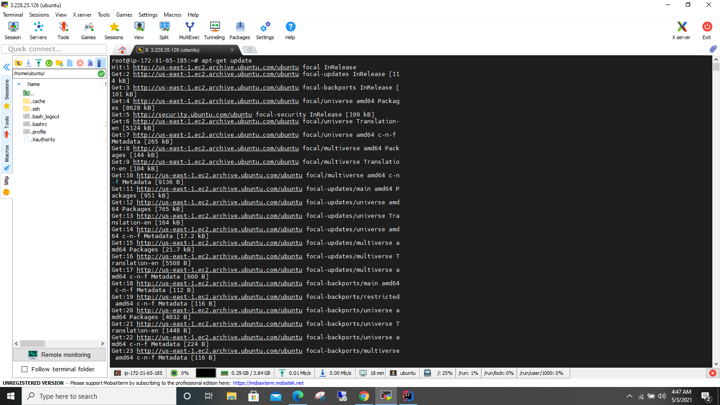

Step-2-> Installing the default Jre

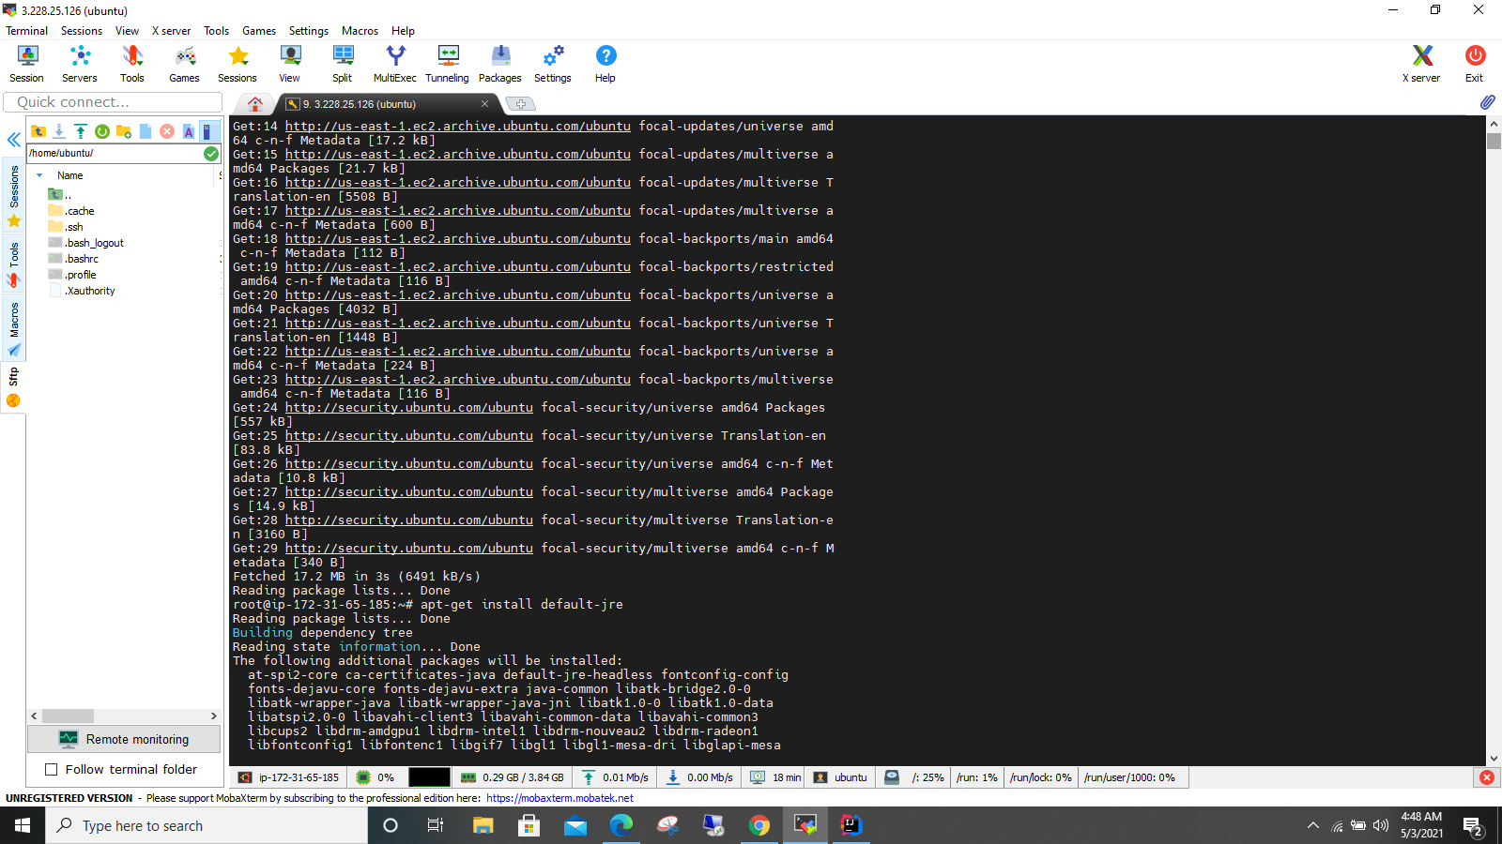

Step-3->Installing default JDk

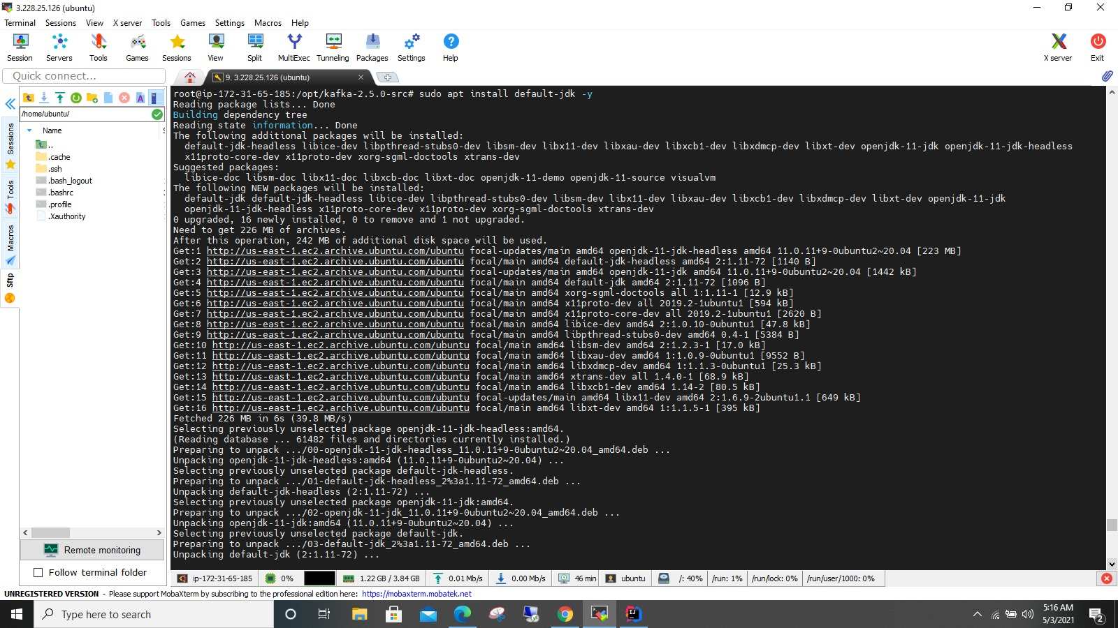

Step-4->Please use java –version to check wheteher the java is installed or not.

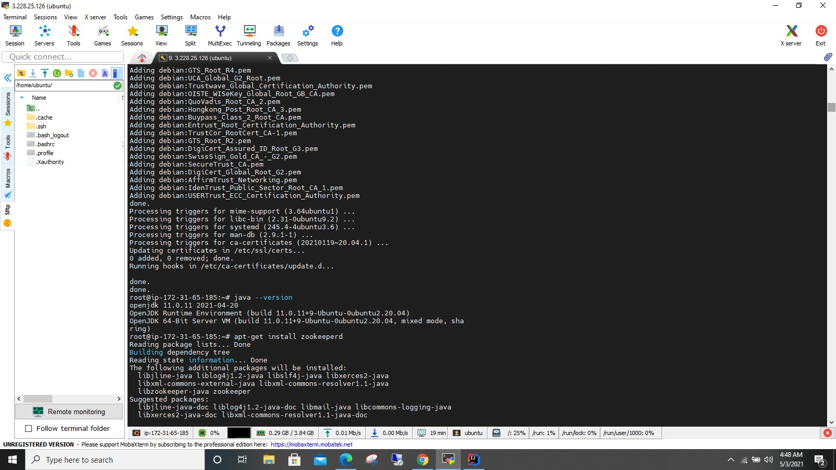

Dtep-5->I nstaall the net-tools to check netstat –nlpt | grep ‘2181’ zookeeper deafult port no is 2181

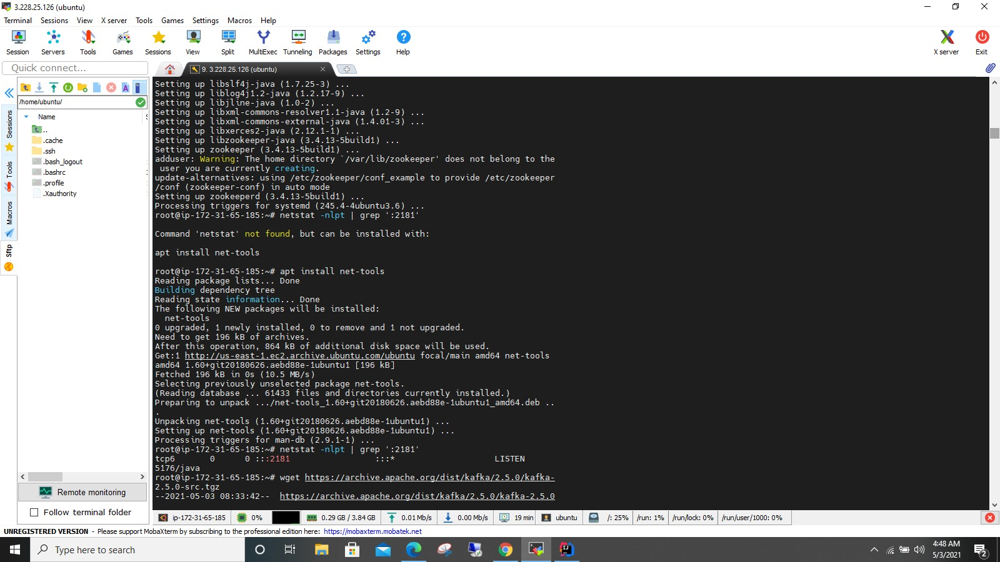

Srep-6- Installing the package by using wget command.

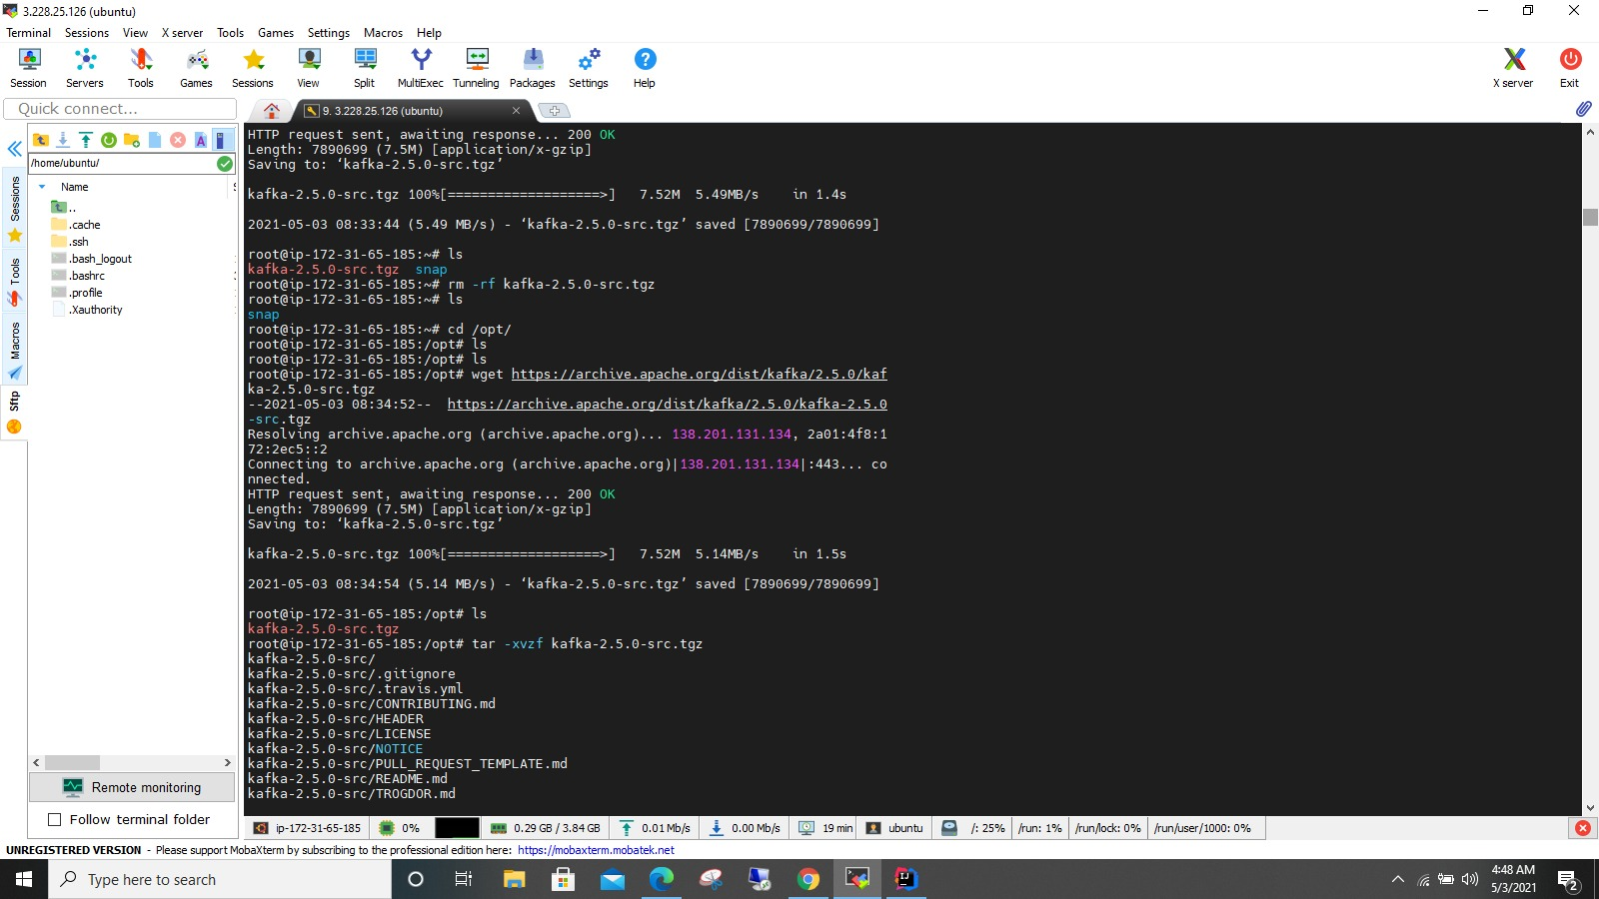

Step-7 -> Cd in to config and vim server.propeties

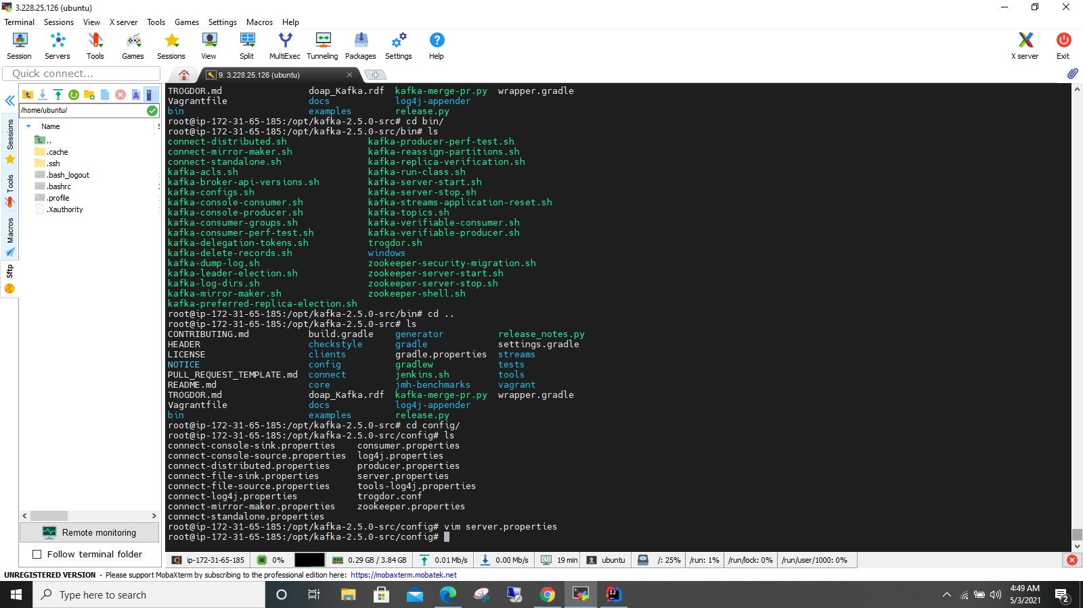

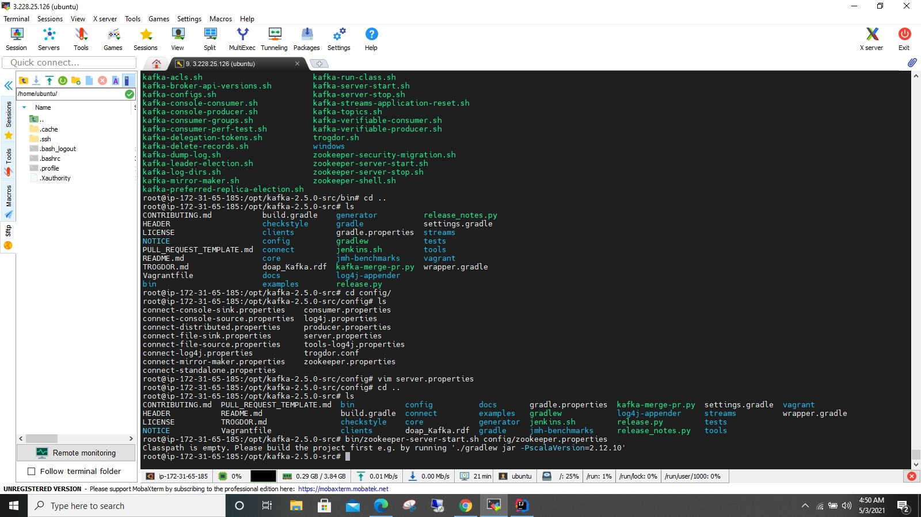

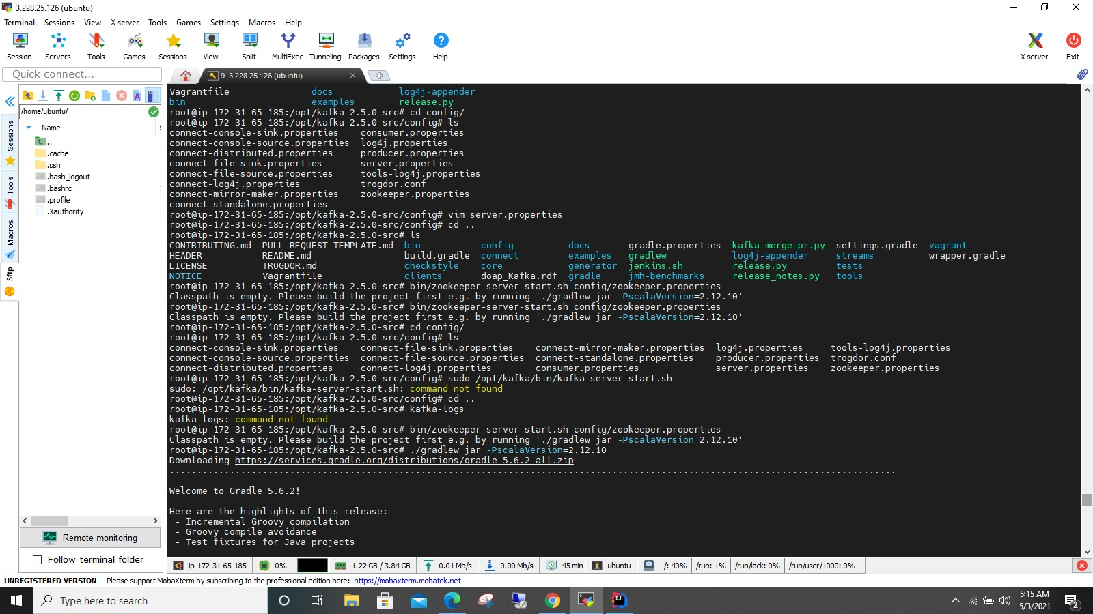

Step-8-> Make sure in server.propeties file we have advertised.listerners in localhost place change it to public ip address.

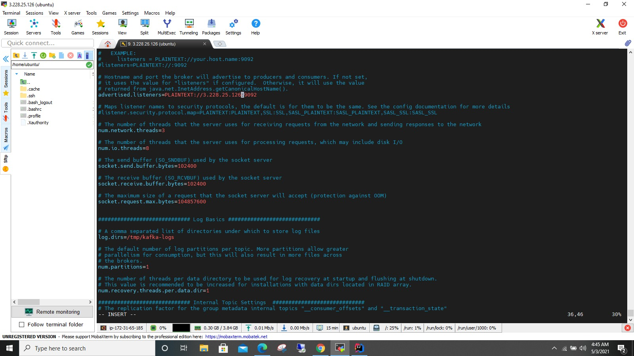

Sstep-8:Zookeeper.connect we need to replace in the place of localhost as our machine public ip.

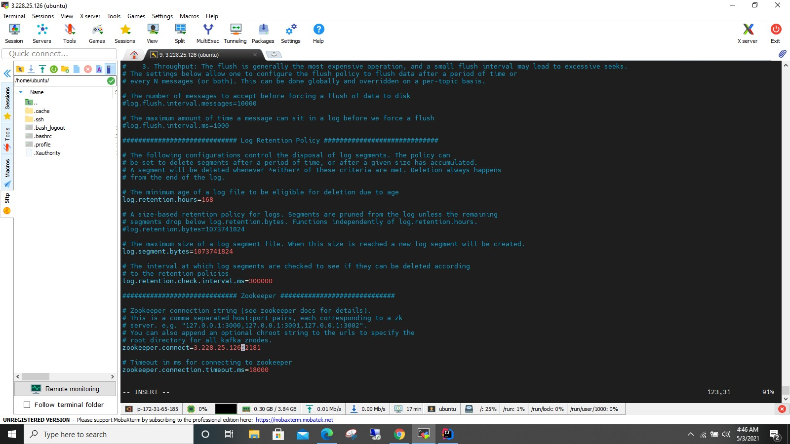

Step-9:we want to make sure to install ./gradlew jar before lanuching zookeeper and kafka.

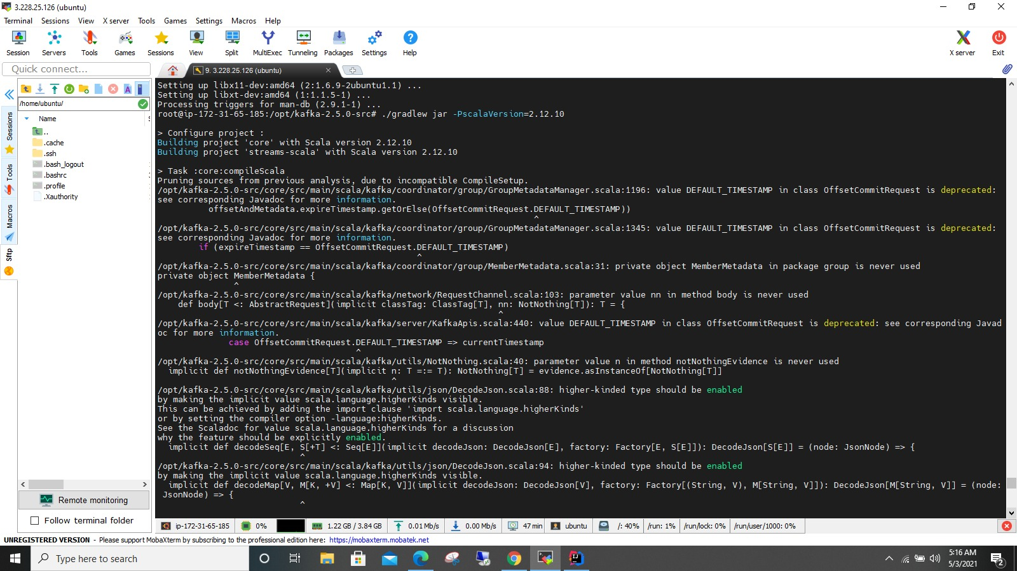

Step10: Use bin/zookeeper-server-start config/zookeeper.properties cmd to run zookeeper server berfeore running kafka server.

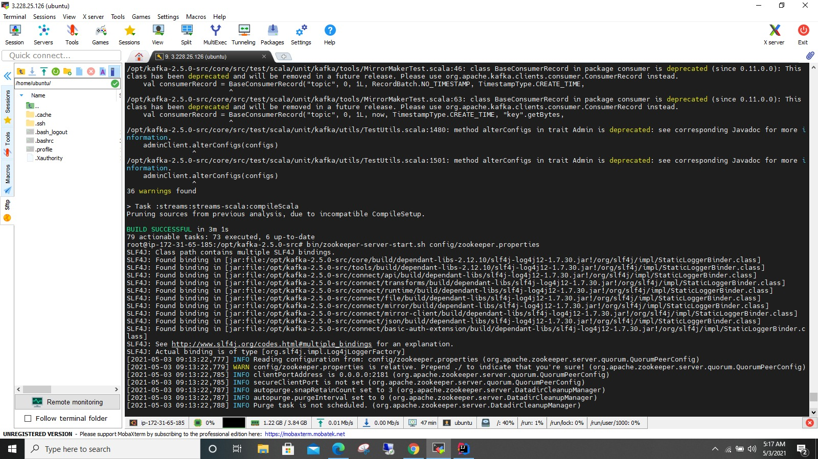

Step11:Use JMX_PORT=8004 bin/kafka-server-start.sh config/server.properties to start the kafka on port 9092 kafka’s default port

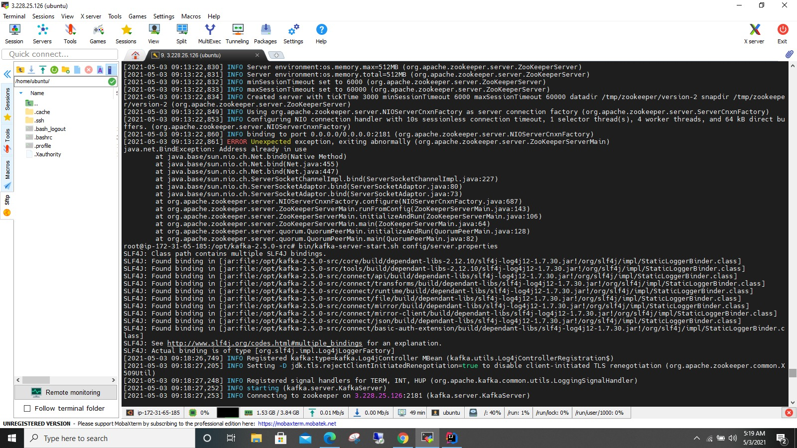

Step 12: Started the Zoomkeeper.

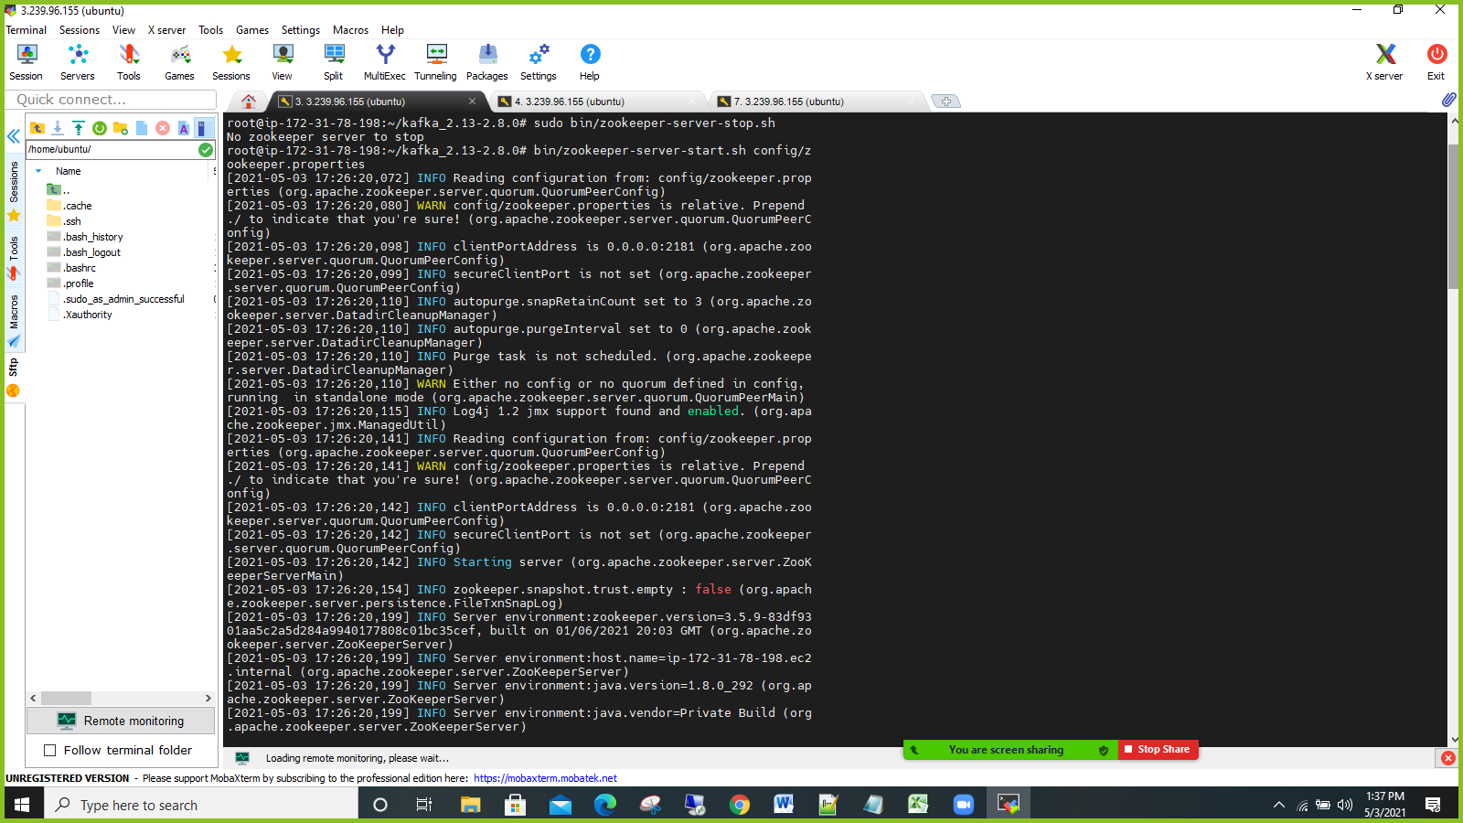

Step 13:Satrted Kafka

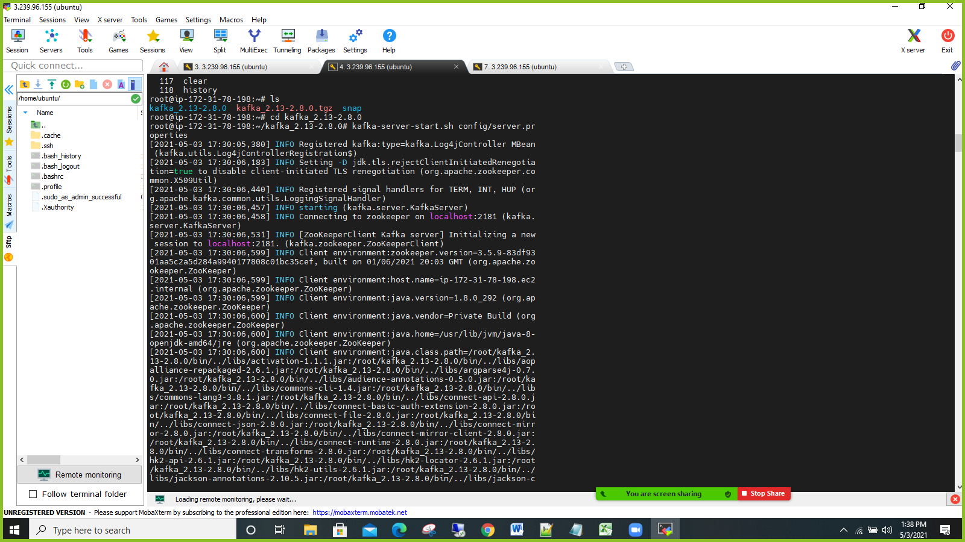

Step 14:Started ELK

